Aberystwyth Municipal Cemetery
Historical reference

1857 – Present day

M. Lloyd-Evans: Aberystwyth 2009

History

1.1 Background:
Prior to the Cemeteries Clauses Act of 1847 and the Burial Acts of 1852 (which only applied to London) and 1853 (where the provisions of the 1852 Act were extended to the rest of the country), most people were buried in churchyards. Demographic changes brought about by the Industrial Revolution resulted in a significant increase in population in certain parishes, and as death follows the living wherever they go, the overcrowding of the parochial churchyards became a serious health hazard. This lack of churchyard space coupled with the increasing agitation between the Anglican Church and the Non-Conformists in regard to churchyard burial practice necessitated the creation of new burial grounds. The Industrial revolution also created a new hierarchy of wealth and poverty which impacted on the municipal cemetery as a form of class structure and populist consumerism. Similar to the practice of intra-mural church burials, the grave marker and situation of the grave within the cemetery signalled a family’s importance in the community. The elaborate grave marker and prominent burial site no longer belonged solely to the landed gentry.

Municipal cemeteries emerged as a direct legislative response to various burial problems including those of overcrowding and disease in established churchyards and the discontent of non-church members. The Burial Acts of 1852 and 1853 empowered parish vestries to establish Burial Boards to form new parochial cemeteries; an area of ground where there was to be both consecrated (Church) and un-consecrated (Dissenters) burials. The finance for the purchase of the land was either to be taken directly from the Poor Rate or borrowed against the security of the Rate. A consolidating Act in 1857 introduced Town Councils, Local Boards of Health and Improvement Commissioners to the Burial Boards and each council was permitted to levy Burial Rates if necessary. The Burial Board was expected to keep an account of all the cemetery’s financial and administrative dealings in specially printed ledgers and registers.

By 1860 the economic status of Aberystwyth was changing and there appeared a new social structure. There was a rapid growth in population and Aberystwyth became a community of craftsmen, both industrial and domestic, and shopkeepers. There was no longer a reliance on the landed gentry for generated income. Within Aberystwyth, politics and religion were often seen as one akin to the other. The Anglican Church was the religious counterpart of the Tory Corporation, and often there were close family relationships between church incumbents and the landed gentry. At the turn of the nineteenth century, the growing popularity of non-conformity reflected the widespread antagonism towards the established Church, especially within the labouring classes. The ‘old’ upper class still supported the Anglican Church, but the new (mercantile) upper social class did not. as the allocation of grave spaces within the cemetery will illustrate.

  - Establishment
Unlike the churchyards, the Church had no jurisdiction over the management of the new cemeteries. In accordance with the Burial Acts the cemetery was to be managed by a committee of local rate-payers. This committee was to be known as the Burial Board. It was the duty of the Parish Vestry to appoint ‘not less than three and no more than nine persons, being ratepayers of the parish, to be the burial board of the parish. Each year one third of the Board were to be replaced with newly elected members. Previous members were allowed to be re-elected from time to time. There were no religious sanctions imposed upon the election of members, both Anglican and Dissenters were eligible to hold office as long as they were ratepayers. According to the Burial Acts any Board vacancies were to be advertised and filled within one month of the removal of the previously elected member. The Board was to meet at their office (if one was available) or in another convenient place to which the public had been notified and was empowered to hire the staff necessary for the management of the cemetery. The clerk was held responsible for the cemetery record keeping. Various record books were printed to allow, amongst other things, the documenting of the minutes from all the board meetings and the financial records (income and expenditure) with regard to the cemetery. The clerk was also responsible for collating the burial notices and instructing the cemetery keeper with regard to the burials. (the Burial Board continued to supervise and maintain the cemetery until the Local Government Act of 1894 transferred its duties to the parish and urban district councils).

Although Aberystwyth cemetery opened in October 1860 negotiations for the purchase of a parcel of land suitable for the creation of the new municipal cemetery had begun in 1857. The first documented meeting was held in October 1857 at the office of the newly elected Burial Board (possibly the church vestry) to discuss the suitability of a piece of ground belonging to Colonel Powell of Nanteos, a local landowner. The land considered was situated on the outskirts of the borough of Aberystwyth and made up of sections of two fields near Llangawsa (fig.1)

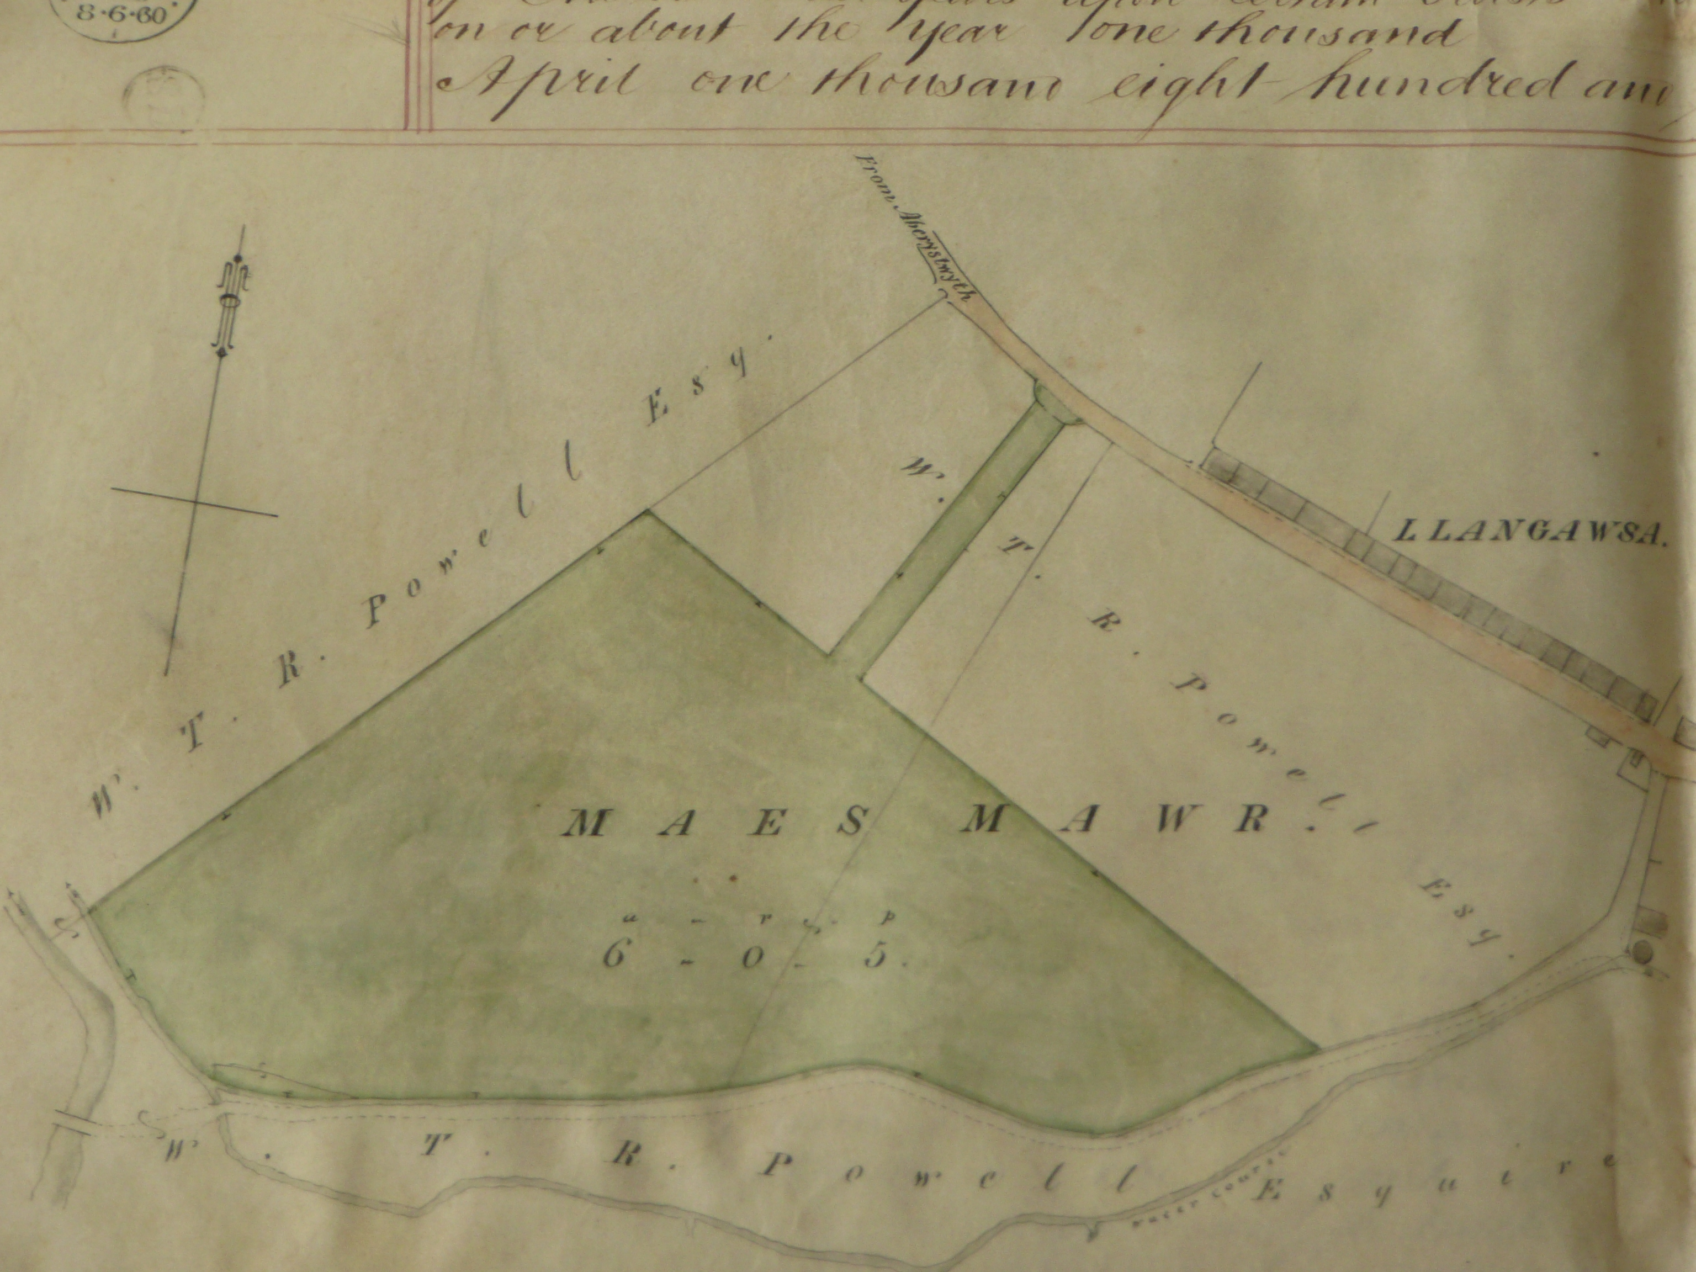
Fig.1 Plan showing the site of the proposed cemetery

When considering the positioning of the cemetery the board had to take into consideration both the 1847 Cemeteries Clauses Act as well as the newer Burials Acts. The 1847 Act stated that cemeteries were not to be situated anywhere near habitable premises. A mandatory distance of two hundred yards was prescribed, unless they had written consent from the owner, lessee or occupier of the property. This distance between the cemetery and any dwellings was amended to one hundred yards by the 1855 Cemetery Clauses Amendment Act. The geographic situation of the land near Llangawsa close to the boundary of the town satisfied the aforementioned Burial Acts and Home Office criteria namely that it was (just) outside the town boundary, a safe distance from any dwellings and was easily accessed by the general public.

From the Aberystwyth Burial Board minute books it would appear the main topic for discussion in the majority of the board meetings (1857-1866) was the consideration of acquiring the necessary monies to create the new burial ground and for the building of two chapels (and possibly a lodge) at the site. The Burial Acts dictated that the finance for the purchase of the land was either to be taken directly from the Poor Rate or borrowed against the security of the Rate. In order to construct the Chapels another loan was considered by the Burial Board. Having deferred the decision on the loan at the meeting held on December 23rd 1863, the Board decided to continue enquires early in 1864. A sum of £1000 was required to be borrowed for the building of the chapels, and for planting and laying out the burial ground and the sanction of the Vestry of Ratepayers for borrowing this sum had be obtained.

From the beginning the Burial Board were determined to provide the inhabitants of Aberystwyth with an enclosed burial ground, complete with two chapels and a cemetery lodge, whose gates would be secured during the hours of darkness. However it was to be four years (approximately) before the chapels were erected and thirteen years before the lodge was built. The exact date of the chapels’ construction cannot be validated as the cemetery records cease after the above entry and, unusually, there is no mention of the construction or opening of the new chapels in the local newspaper The Aberystwyth Observer. Unfortunately both chapels have now been demolished and the ground re-used as burial plots.

At the April meeting in 1860 the board met to determine what buildings (if any) should be erected at the cemetery and to consider a plan for a gate at the entrance to the cemetery. It was decided not to proceed with the buildings until a later date and for the new gate at the entrance (from Turnpike Road) be ordered from the Coalbrookdale Company according to a design of pattern produced by Mr Richard Jones numbered 72. The width was to be 11ft 4 inches. These gates were to be erected with as little delay as possible and that the walling and other work proceed under the supervision of Mr Pugh, Surveyor. Twelve years later the cemetery gates were in need of repair. At the public meeting of 23rd August 1872, the state of the cemetery gates was brought to the public’s attention by Mr J.W. Szlumper who commented ‘the beautiful iron gates were out of order, the handles were knocked off, and the lock would not act for the want of a drop of oil’(Aberystwyth Observer, August 24th 1872). The original gates still hang at the main Llanbadarn Road (formerly Turnpike Road) entrance and are now being renovated.

Even before the land for the burial ground had been purchased the Burial Board was making representations to garden contractors regarding the cemetery layout. In January 1859 an application was made to Messrs Dickson & Sons of Chester regarding the terms for undertaking the laying out of the burial ground. In order to prepare a quotation Messrs Dickson & Sons stated they would have to view the site first. They were duly invited to Aberystwyth and the following month presented the board with a sketch of the burial ground as they would lay it out. It was decided that the board would instigate the preparatory work in the cemetery by levelling the ground and doing all other necessary works for preparing and making it suitable for a burial ground. Mr George Pugh was to employ persons to “raise stones” from Buarth Mawr quarry for erecting the walls required for enclosing the said burial ground.

In July 1859 the board called for tenders for erecting a stone wall to enclose the burial ground. The tenders were to be in before the 16th August. An advertisement, dated July 22nd 1859, containing explicit instructions with regard to the walls construction, duly appeared in the July 30th edition of the Aberystwyth Observer. The tender from Jenkin Jones and David Jenkin Jones, masons was accepted. however it would appear that the Burial Board did not use these masons as on the 8th October a letter of complaint was sent to Thomas Davies, mason, Aberystwyth regarding the erection of the cemetery wall.

Although Messrs Dickson & Jones were to be responsible for the planting of trees and shrubs in the cemetery they are quoted as being seedsmen in the cemetery cashbook. It is assumed that their duty lay in the seeding of the burial ground rather than the planting of shrubs as apart from the payment of £14-8s-6d in the August of 1860 no other mention is made of the organic management of the cemetery save for the selling of hay.

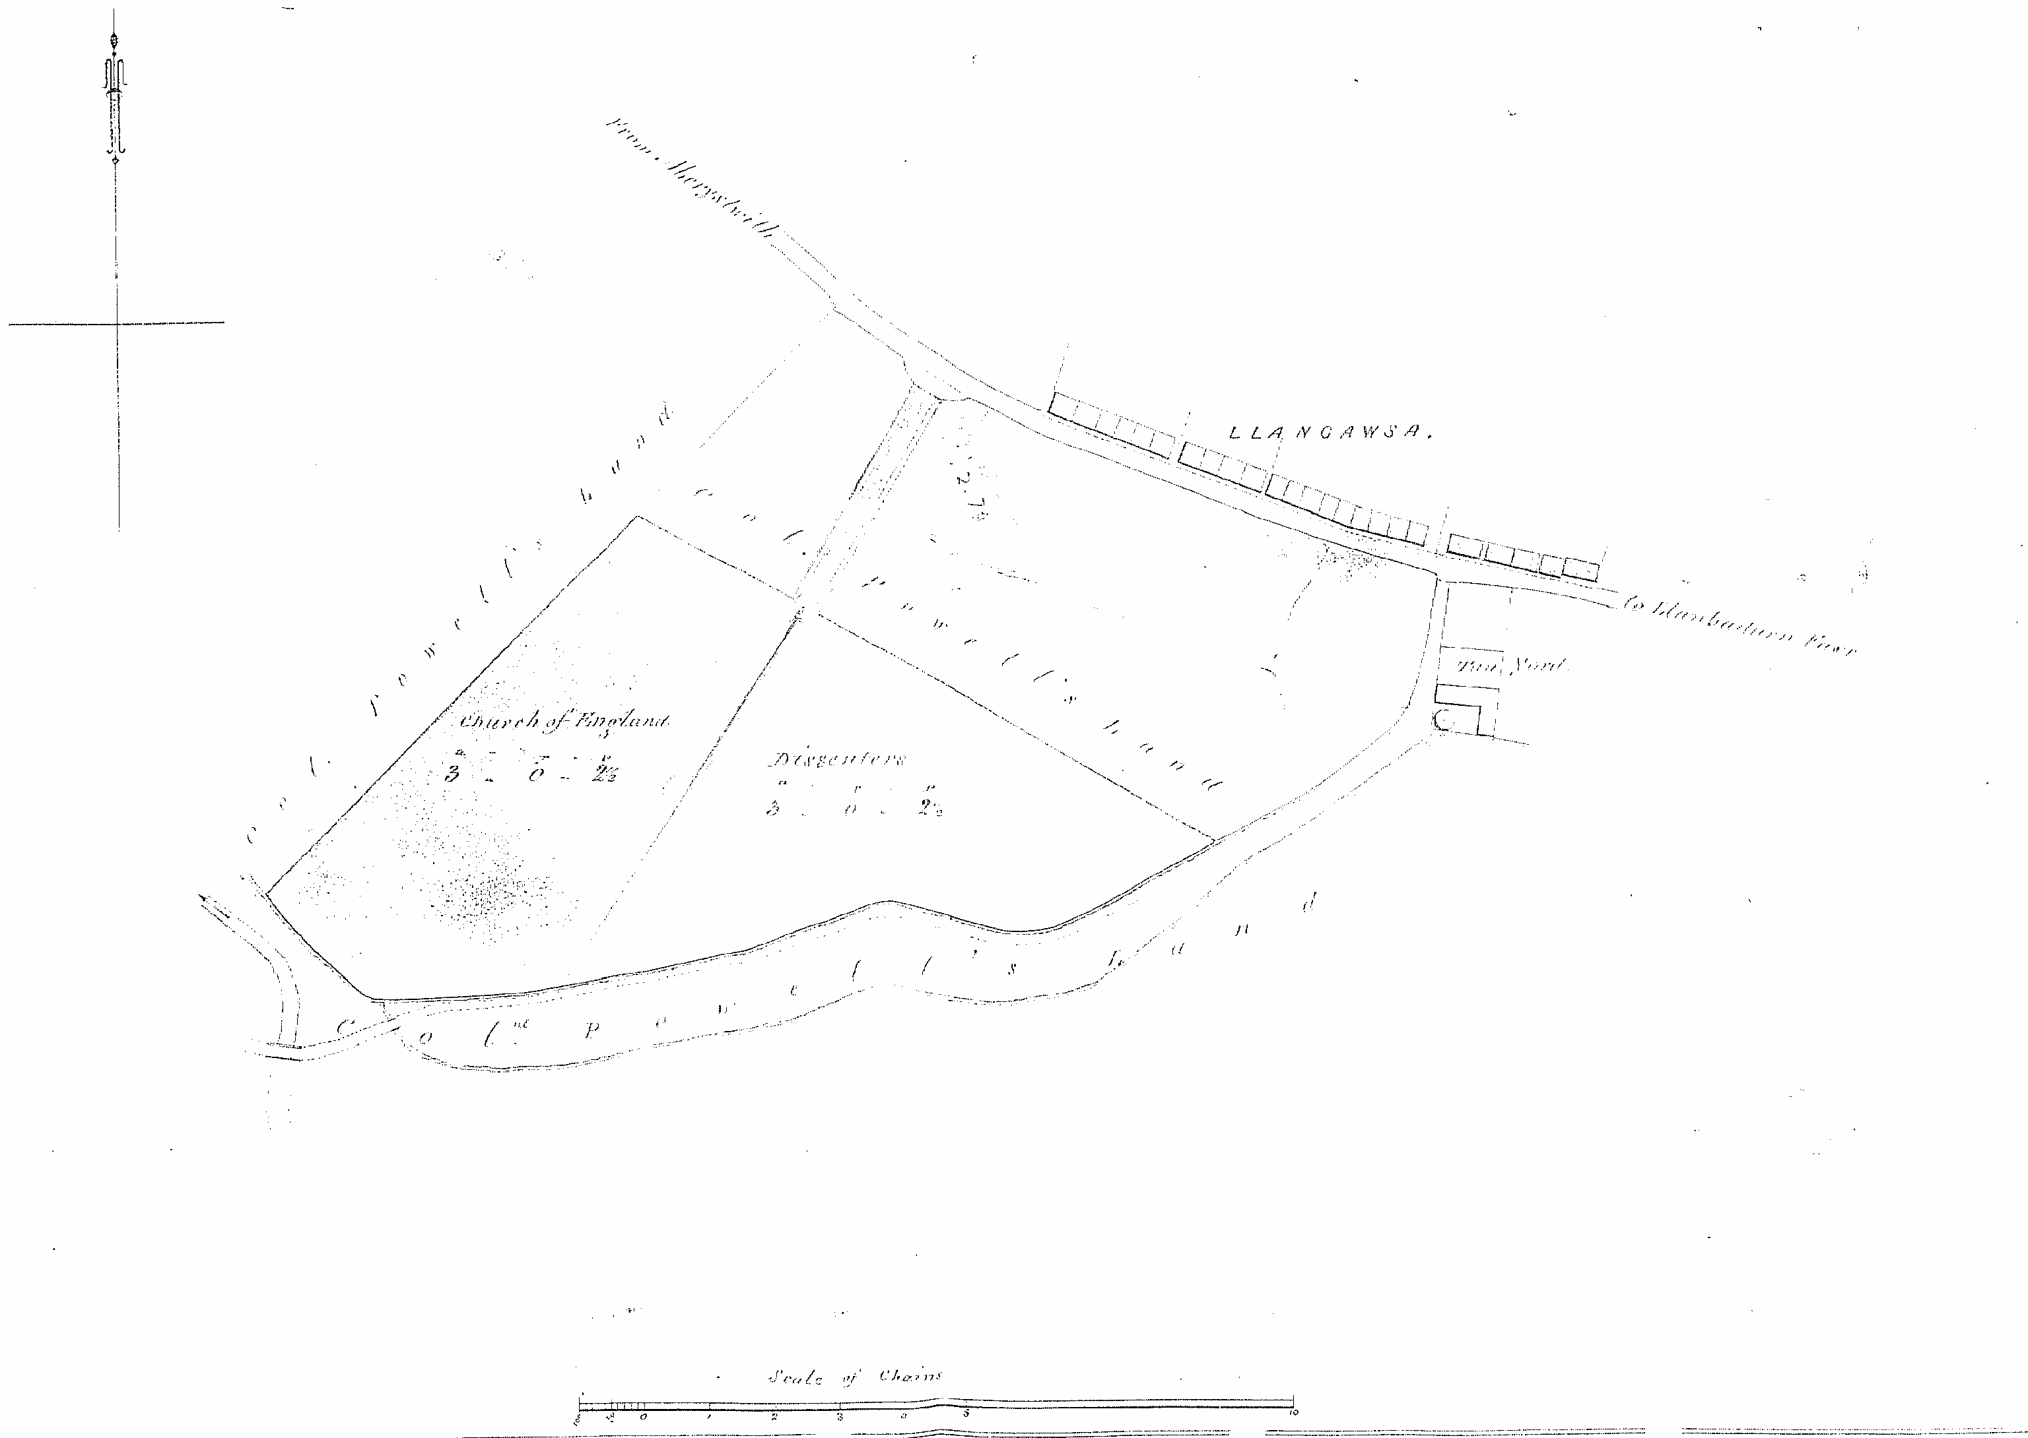
On 3rd April 1860 the burial board had to determine what proportion of the burial ground should be laid out into consecrated and un-consecrated and in what manner and in what portions the un-consecrated parts should be allowed. It was decided the cemetery should be divided into two equal parts – as per surveyors plan (fig.2)

Fig.2 1861 Surveyors plan showing the Church/Dissenters divisions of the cemetery

The cemetery plans of the plot divisions into class and section however were not drawn up until October 1861 after a lengthy meeting of the local Burial Board. As social order is always expressed in some kind of hierarchy, the two religious sections are likewise broken down into classes, 1st, 2nd and 3rd. First class being for the rich and important section of the community (upper classes are assumed by everyone including themselves, to hold very desirable places in society), second supposedly for the trade or middle class and third for the poor. Although Messrs Dickson & Son’s had been approached (and paid for) plans for the laying out of Aberystwyth cemetery, the arrangement of the different social divisions and the grave spaces therein was left to George Pugh the borough surveyor. In October 1861 he produced a plan showing the cemetery divided into two equal areas, one for consecrated or Church burials and the other for un-consecrated or Dissenters burials, these areas were further subdivided into three classes: 1st; 2nd and 3rd. This division of the cemetery was still not implemented by the March of 1862 as the board requested Mr Pugh to complete the plans showing the grave spaces marked thereon, with as little delay as possible. A Mr McArthur of Crygie was to be engaged to layout the burial ground in November 1862 however as John Thomas, gravedigger, stated later, Mr Pugh did not present the plans to the board until 1864 or thereabouts, it seems unlikely Mr McArthur was employed. The plans of the cemetery grave spaces were drawn on sheets of vellum. The original burial sheets (currently held at the Lodge, County Sexton) were individual pieces of vellum bound together to form a loose, soft covered “book” which measured approximately eighteen inches by twenty four inches. There was to be a separate “book” for each of the two denominations – Church and Dissenters. Each “book” was divided into the different classes and further sub-divided into the relevant numbered sections, with each page representing one complete section of the cemetery (fig.3)

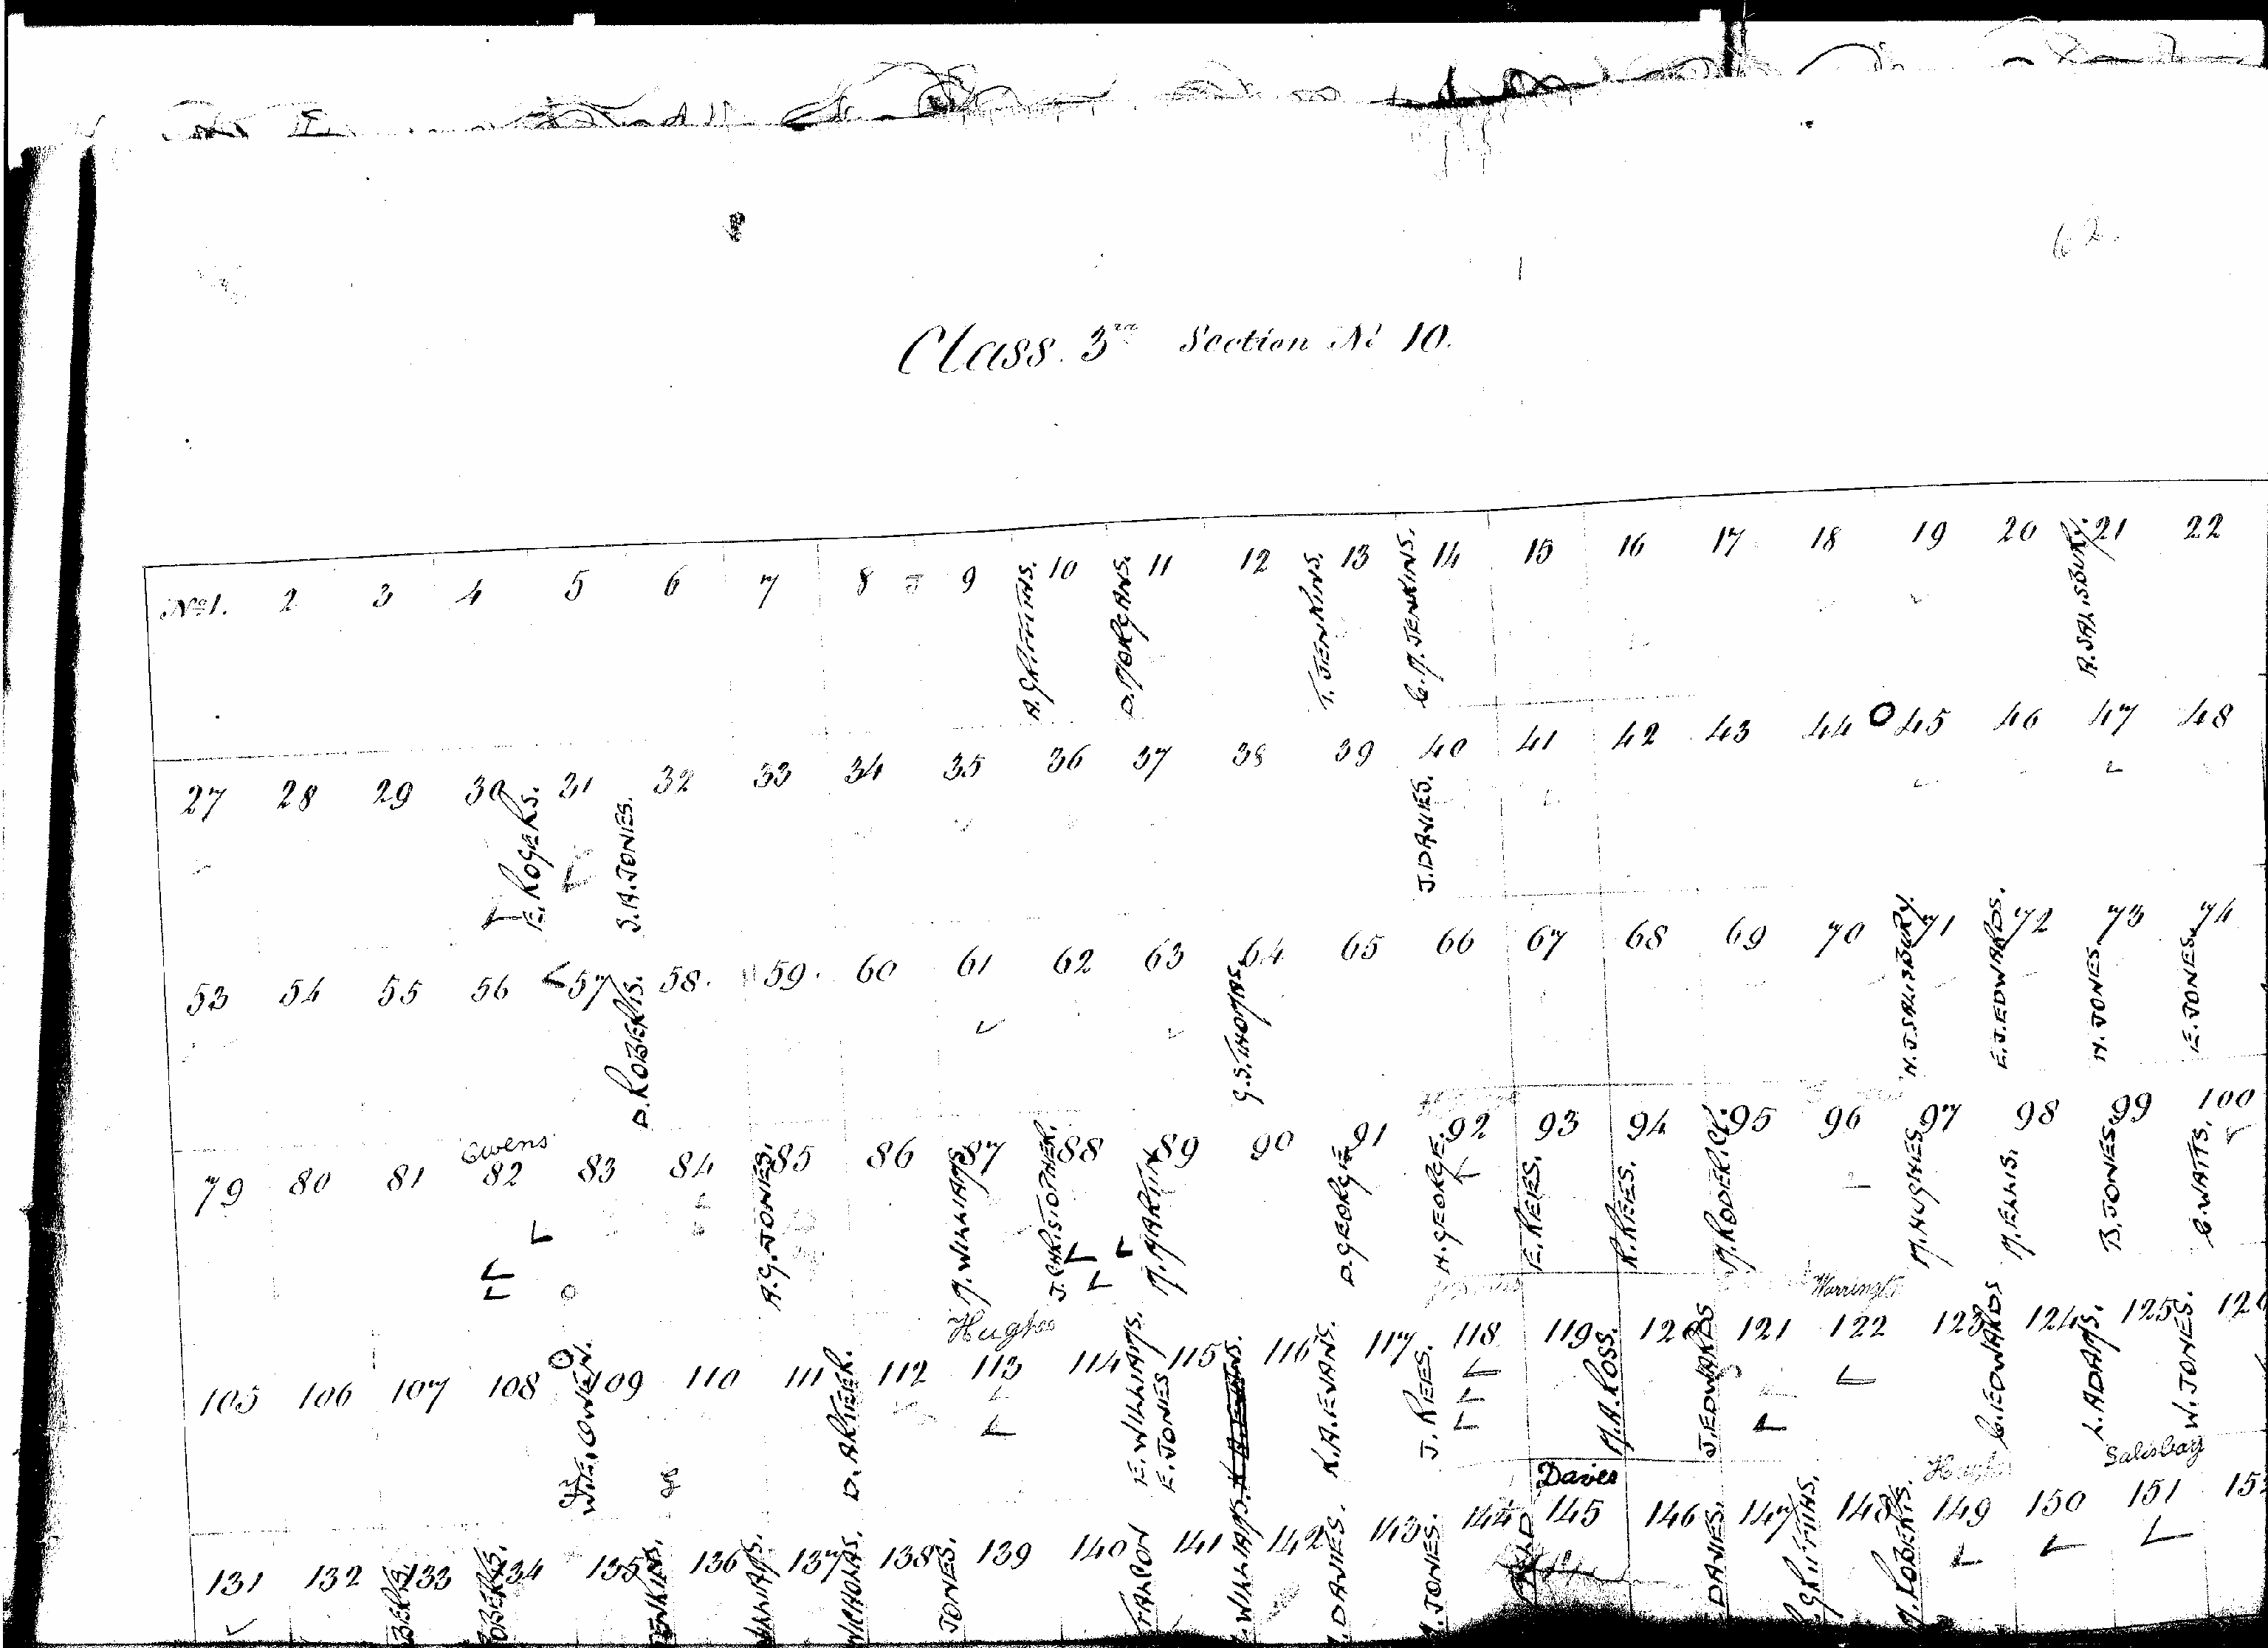

Fig. 3 Section of the original vellum sheets showing the individually numbered grave spaces in Class 3 Section 10 (un-consecrated). To indicate a burial the surname of the deceased was written on the sheets. Another way to signify a burial was to place a √ on the grave space. Each √ represented a single burial

Although the cemetery acreage was divided equally there was a sizeable difference in the religious division of Class with the Church section being allocated a greater number of first class grave spaces than the Dissenters section. Both the Church and Non-conformity adherences are represented in the table below which illustrates the religious division of burial spaces available within each Class.

CLASS | CHURCH | DISSENTERS
1st | 1317 | 850
2nd | 1069 | 1286
3rd | 1303 | 1553
Total | 3689 | 3689

It is noticeable that although both halves have exactly the same number of plots, the class division totals differ quite considerably between the two religions. The unequal class divisions of the cemetery plots indicate the religious preferences of the separate classes of the population, for instance, there are more first class plots on the Church side than the Dissenters, even in 1860 Aberystwyth was still predominantly a gentrified area and if a person could afford it “First class church” was the place to be buried. The new upper class (trade) were almost always buried within the Dissenters side (Fig.4)
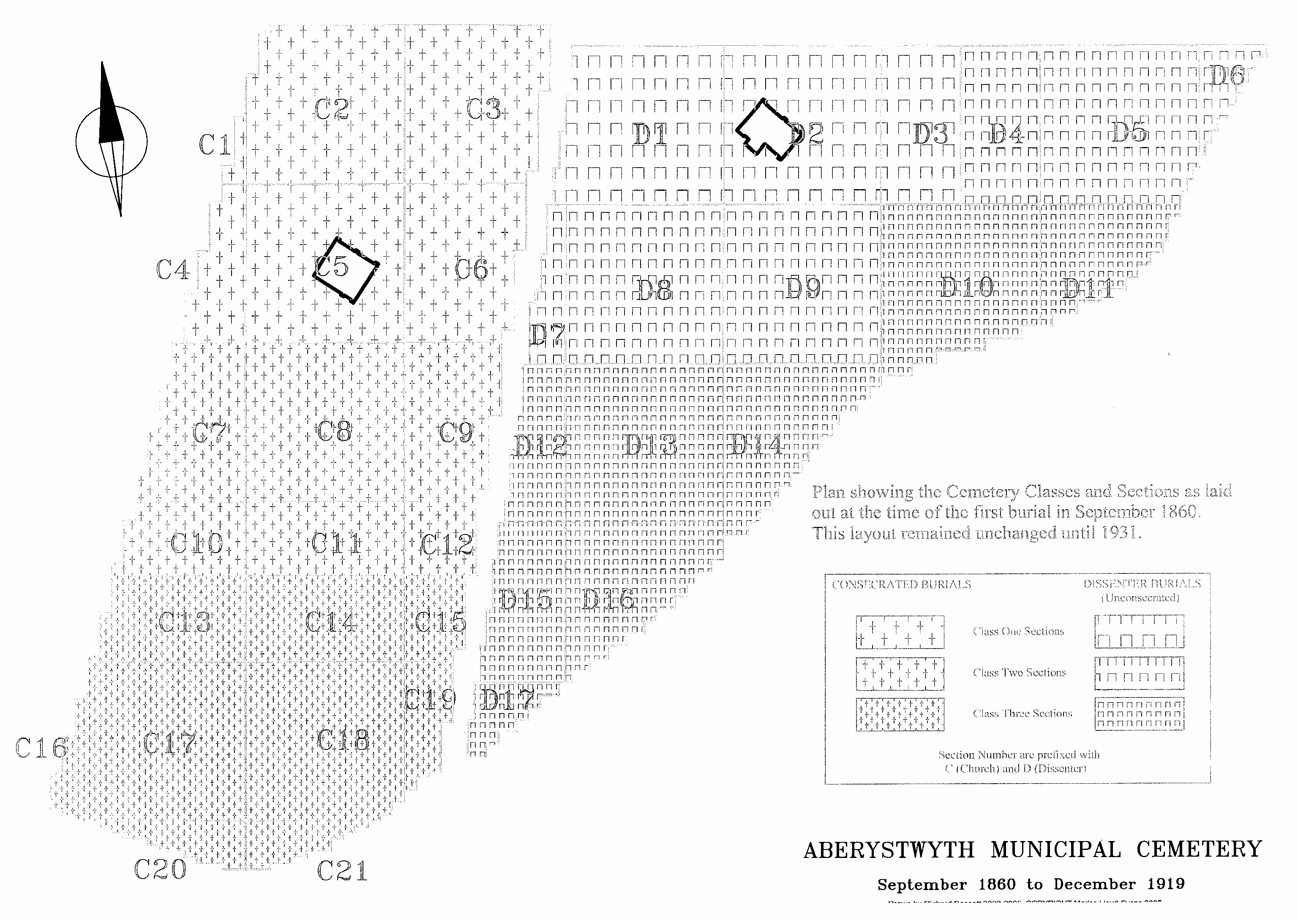

Fig. 4 Plan showing the division of the cemetery into religion, class and section.
Throughout history, social status has manifested itself in a hierarchical system designed to keep the different classes of society separated. The elite would always remain above the lesser ranks. Therefore the position of the grave space was of the utmost importance, as the placement of the deceased within the cemetery was to be seen as an extension of their perceived status in life. In Aberystwyth cemetery, Class 1, in both areas, is situated at the top of the slope, nearest the entrance, Class 3 is the section furthest away from the entrance (and also at the base of the slope) and Class 2 is sandwiched in-between. The graves spaces are uniform in size and shape and are numbered consecutively from 1 to the end within each class. The Church grave spaces have an East-West orientation while the Dissenters graves face North-South. The writer has been unable to determine why the Dissenters graves spaces were laid out in this way. It is probable that due to the shape of the cemetery on the Dissenters side, the North / South axis produced more grave spaces than an East / West aspect would. The numbering of the graves in the Church section is identical to the Dissenters but due to their orientation, adjoining family grave spaces in the Church section are situated in different rows.

According to the burial registers the first burial in Aberystwyth cemetery occurred on 1st September 1860 with the interment of David James Lloyd, the three month old son of David Lloyd, Draper. As this register is a copy made from the “many pieces of paper” referred to in the 1872 Home Office enquiry the information imparted may not be correct as the headstone records the name of this child as Daniel James Lloyd!

The Anglican section of the cemetery was finally consecrated in June 1873. The minutes of the meeting held on 23rd May record “The Seal of the Board to be affixed to a Memorial to the Lord Bishop of St David’s praying his Lordship to consecrate the cemetery on the 3rd June next and the clerk to send a copy of the cemetery plan to the Bishop’s secretary”. On the 20th June 1873 a cheque of £10-15s was sent to John Thirwall, secretary to the Bishop of St. David’s as payment for the fees etc. for the consecration of the cemetery.

Both the Burial Acts and the Home Office Rules and Regulations stipulated the size and depth of the grave spaces. The official regulations, which had been sanctioned by Parliament, required the minimum size for a grave space for persons above twelve years of age was to be nine feet long by four feet wide or four square yards, In the March of 1861 the Board decided that all the grave spaces were to be eight foot by four feet. There is a wide variation in the depth of individual graves within Aberystwyth cemetery. The original Aberystwyth Burial Board (1860) decided that nine feet should be the optimum depth for the first and second class grave spaces, with the proviso that any person wishing to purchase a grave or vault deeper had to have the boards’ permission. In the ordinary graves (third class) where the exclusive right of burial had not been purchased the depth was not to be beyond five foot except with the special permission of the board.

In 1872 public concern about the financial dealings of the cemetery prompted eminent Aberystwyth ratepayers to demand a vestry meeting in which the management of the cemetery was to be discussed and if necessary a new burial board be appointed. The parishioners were notified of the date of the meeting (23rd August) by means of a notice being posted on the doors of St Michael’s church. At the meeting the parishioners agreed that the original board no longer existed, or in the words of Mr Philip Williams “the Burial Board is extinct”, and that the Vestry was qualified to elect a new board. Following a heated debate it was decided to write to the Home Office and ask for an official investigation into the previous management of the cemetery. In August 1872, Mr T.P. Holland (Home Office Inspector) arrived in Aberystwyth to conduct an official inquiry.

At the inquiry the Inspector was informed of the irregularities of the cemetery management, both financial and administrative, and asked for his opinion and advice. He was scathing about the lack of cemetery direction and brought to account the gravedigger and the vestry over the lack of official recording of burials. The assembled members of the public, which included members of the burial board, were informed that “someone should be employed to keep the books, and that all the books should be kept together in a cemetery office”. The vestry clerk proposed a lodge, Mr Holland proposed a cottage! The preferred site was a piece of land, measuring 40ft x 80ft (approximately ¼ acre) which was situated on the Llanbadarn side at the entrance to the cemetery.

Following on from this inquiry the post of ‘cemetery keeper’ was advertised in the Aberystwyth Observer, Cambrian News, The Welshman and Carnarvon Herald. The cemetery keeper would be required to devote the whole of his time to the duties of his office. Candidates must be conversant with both languages (Welsh and English) and be a good gardener. According to the advertisement for a house was to be provided for him rent free, the assumption being the cemetery lodge was to be for his use, yet the lodge was originally built for the sole use of the burial board. In September 1874 the cemetery keeper asked for the lodge to be altered so that he and his family could move in. The board unanimously decided his application was to be refused. It was not until November 1875 after Mr David Jones, builder, had written to say the proposed alterations to the lodge could be done, that Evan James’ (third) application was granted. The lodge still stands at the entrance to the cemetery providing passers-by with the opportunity of viewing the building practices favoured by the architect such as the red banding and the ornamental style of window.

Until 1872 there are no references to the trees and shrubs used to border and decorate the cemetery. In December 1872 the tender from Mr James Dickson of Chester was accepted for the planting of the cemetery on condition that ‘he was to replace all the trees that failed to survive within three years of planting’. In order to prepare the ground for planting the board arranged a meeting with the gardener from Cwmcynfelin (the mansion situated on the Clarach Road) on 28th December at 11am. In February 1873 the board wrote to Mr Dickson deferring the planting until the November and at the same time authorised the cemetery keeper to ‘procure a man to assist him (the cemetery keeper) in preparing the ground for planting’. The trees must have been delivered earlier than November as the minute book records the sale of the spare trees in the October of that year.

For the next twenty years the cemetery trees were continually being moved and thinned out. The construction of paths around the edge the cemetery meant the uprooting of some of the trees which bordered the burial ground. In January 1875 the spare trees in the cemetery were sold to Captain Lewis at the price of 2s-6d. He had to remove the trees from the cemetery within the month. The board also decided that the cemetery keeper, from time to time, was to sell the ‘prunings’ of the trees and shrubs in the cemetery at a price to be fixed by him. Apart from the one entry in 9th April 1875 for the purchase of ivy plants from Messrs James Dickson & Sons, Chester, none of the trees or shrubs purchased are mentioned by name.

Many of the trees and shrubs must have been retained in the cemetery for many years as their increasing height and spreading root system caused some problems. In March 1914 the parents of the deceased Miss A Brett, 10, Princess Street, Aberystwyth asked for the removal of a growing tree close to their daughter’s grave. Although no reason was given for this application and no further information regarding the tree was entered into the council minutes the tree must have been removed, as there is no evidence of any planting in that section. As the need for burial plots increased, there can be no doubt many of the ornamental trees and shrubs were removed due to the utilisation of former pathways as new grave spaces.

1.3 Cemetery Rules and Regulations

Despite continually referring to the cemetery rules and regulations the board failed to insert a copy of the rules/regulations in the minute book. However two entries from 1861 could be considered as such. On the 19th March 1861 the board decided that grave spaces for the burial of persons sixteen upwards should be 8ft x 4ft, and that no grave or vault be excavated beyond the depth of 9ft except with special permission from the Burial Board. And that in ordinary graves, where the exclusive right has not been purchased the depth should not be beyond 5ft except with special permission of the board. At the December 1863 meeting it was recommended that ‘no monuments or gravestones were to be allowed to be erected or put upon any grave on any part of the Burial Ground (Class 3) where the exclusive right of burial either in perpetuity or for a limited period has not been granted by the Burial Board. To this end the board instructed Mr Spaull ‘to prepare and send to the Burial board designs of suitable headstones upon graves in the third class’. According to the board minutes the cemetery rules and regulations were amended in 1875 ‘in the way suggested by the Inspector of Burial Grounds’
Having accepted the transfer of the cemetery in 1898 the council minutes of Aberystwyth Urban District Council only record the labour sheets and bills of the cemetery. That is until 1916 when the minutes begin to list the grants of grave spaces and any other incidentals regarding burials at the cemetery. The maintenance of the cemetery and its rules and regulations are not mentioned as the running of the cemetery was handed over to the Public Works committee.

The first (cemetery) record in the minutes of the Public Works committee was a complaint from Mrs Phillips, the widow of Dean Phillips, which referred to people trespassing in the cemetery. The committee decided to ask the police for their assistance with the view that if the trespass continued then charges would be brought against the offenders.

By 1919 the cemetery was nearly three quarters full and it was impossible to pre-purchase a grave space (fig. 5) In later years as the cemetery filled and burial plots in classes one and two were no longer available, both class three sections of the cemetery were re-designated class two (possibly due to the sensibilities of the local population with regard to burial in the poor section of the cemetery).

Fig.5 Plan showing cemetery burials 1860-1919.

The continuing history of the cemetery is one of shameful neglect. Once again the initial proceedings progressed at an impressive pace, but all too soon the cemetery became a burden. The Cambrian News was continually filled with complaints regarding the cemetery management and maintenance. One only has to look at the limited information contained within the local records to appreciate the attitude of the council towards the cemetery. This unfortunate pattern of neglect and complaint continues to the present day. Financial restrictions ensured the removal of the two mortuary chapels (and lately the removal of the public conveniences) while incompetent management resulted in the cemetery paths being used as grave spaces rather than utilise a new burial ground. Indeed the opening of the new burial ground on Cefn Llan was delayed due to cemetery monies necessary for the laying out of the new cemetery i.e. paths etc, being diverted to other projects. Today the cemetery is closed to all new burials with interment in an existing family plot available to only those with the necessary permissions.

Conclusion
Victorian cemeteries provided the focus for a whole culture of commemoration expressed through elaborate funerals, family monuments, mourning fashions and regular visits to the grave. In Aberystwyth cemetery the majority of the grave spaces were purchased in perpetuity so the memorials erected over the deceased were to be seen as permanent commemorative statements. Made to order and mainly consisting of headstones, these monuments show great stylistic and aesthetic variety as they range from the humble piece of slate in the third class section to the impressive marble statuary found in the first class section. The design of the cemetery reflects a system of differential pricing which in turn ensures the most expensive, therefore the more focal areas, would receive the more impressive memorials. To the Victorians the cemetery was not only a place to bury and remember the dead it was also a source of individual and ultimately civic pride.

Aberystwyth cemetery combines landscape, architecture and monument to form an integrated environment which is defined by a stone boundary on the one side and trees and shrubs (many of which survive from the original plantings) on the three other sides. The cemetery is laid out as a grid, divided equally into Church and Dissenters with each half divided into three classes. Each class is well defined, and therefore easily recognisable, by the memorials within. There is an impressive lodge at the main entrance (which has at last been returned to its original purpose that of a dwelling for the cemetery keeper) but the two chapels have been demolished. The removal of these buildings has transferred the focus away from, and thereby has effectively diminished the importance of, the memorial groupings that are to be found surrounding the chapel sites.

Aberystwyth cemetery provides a social context which is reflected in the cemetery landscape. The proliferation of ledger stones which are only found in the first class Church section and the grouping of the master mariner memorials within second class Dissenters section are only two examples. The situation of the memorial is also important for familial dependency as not all “family” graves are situated next to each other. Removal of a single headstone from its relevant section effectively invalidates all the information contained upon the stone as the iconography and the burial texts contained whereon were as important to the family as the inscription. In addition to its many attributes, as the cemetery was conceived by the living for the dead, it is also a fashion statement. As the cemetery filled the style of cemetery iconography changed, and these changes follow a defined route through the layout of burials.

The lack of council interest in the conservation of Aberystwyth cemetery is a cause for concern as the cemetery is an important part of local culture and heritage and as such should be maintained and protected. Government ministers and Heritage societies are all working closely together to ensure local cemeteries are preserved and a multitude of information is available to all concerned, a few of which are listed under references and bibliography.

References:
Carson, J.E.R. "Aberystwyth - Past and Future: A Summary and Prospect." Aberystwyth 1277-1977 Ed. Ieuan Gwynedd Jones. Llandysul: Gomer Press, 1977.
Carter, Harold and Sandra Wheatley. "Residential Patterns in Mid-Victorian Aberystwyth." Aberystwyth 1277-1977. Ed. Ieuan Gwynedd Jones. Llandysul: Gomer Press, 1977: 46-84.
DCMS 2003 Protecting our Historic Environment: Making the System Work Better.
London: DCMS www.culture.gov.uk
English Heritage 1998 The Register of Parks and Gardens: An Introduction.
London: English Heritage
Jones, Ieuan Gwynedd Jones, ed. Aberystwyth 1277-1977: Eight Lectures to Celebrate the Seventh Centenary of the Foundation of the Borough. Llandysul: Gomer Press, 1977.

